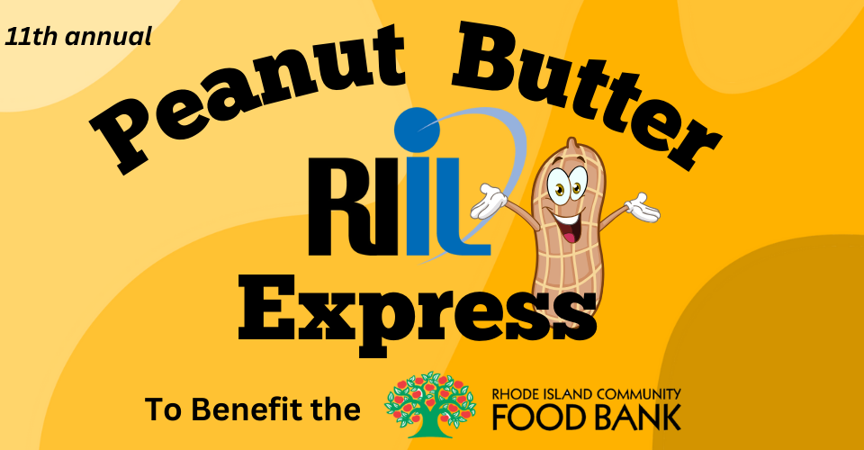

Dear Principals, Athletic Directors & Coaches,

The Rhode Island Interscholastic League would like to invite your school and your student-athletes to participate in a great community service opportunity. The 11th annual Peanut Butter Express to benefit the R.I. Community Food Bank is now underway.

We are asking that you spread the word to your student body and encourage your sports teams to lead the drive. Every jar counts in the fight against hunger, so even a small drive can make a BIG difference.

If your school or team is able to participate, please reply via email to students@riil.org and include the following information:
- NAME OF SCHOOL
- CONTACT PERSON
- CONTACT INFORMATION

Once your collection is complete, please submit the attached recording sheet and a picture of the collected peanut butter. Find all the information you need to organize a collection drive, including customizable flyers, a PSA, suggestions on how to collect the peanut butter and the recording sheet at: https://www.riil.org/page/7300

Please do not hesitate to reach out to the above email with any questions. Thank you for your consideration.

Sincerely,
Carolyn Thornton
Director of Multimedia Content, R.I. Interscholastic League

